Mod 1: Part 2
Investigating MORE Roller Coasters Developed Over the Past 100 Years!

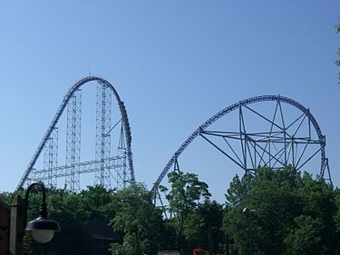
CONTEXT: Amusement Parks are located in various locations across the United States, and many Americans include a trip to an amusement park as a favorite vacation option. These parks often have one or more roller coasters. While not all students have ridden roller coasters before, they have seen them in the media, and the internet is full of videos made by roller coaster enthusiasts. Some parks have older coasters that they have continually maintained over the years, like the Jack Rabbit at Kennywood park, built in 1921 and still in operation today. Many parks, like Cedar Point in Ohio, also continually try to build new coasters to attract new visitors and keep their existing visitors coming back, like the Millennium Force which opened in 2000, shown in picture. Advances in engineering over the years have certainly expanded how coasters are built.
(image from: https://en.wikipedia.org/wiki/Millennium_Force)
In this investigation, you have an opportunity to use CODAP online to explore a sample of 157 roller coasters at parks across the United States.

Getting Familiar with the Dataset
Open the data in CODAP. There are 157 cases, organized hierarchically based on when they were built (the attribute Age Group to the left of the table). Click on the different age groups and explore the table. You can make the Table window larger and also scroll to the right and down to see all 16 attributes and all 157 cases.
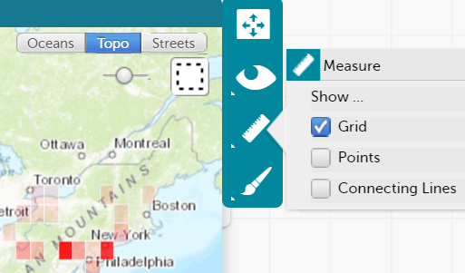
Review the attribute definitions by hovering over the name of an attribute in the column header. The definitions of all attributes are also explained more in the Appendix to this document.
Open the Map (click on Map on the top shelf). Each location of the amusement parks is indicated by a point. Click on the Map. In the Map menu (right-hand side), click on the ruler and change Point to Grid. The rectangular grids shown on the map are different shades of red, depending on how many coasters from that park are in the sample of data.
Click on various grids on the map for a location of an amusement park and then scroll through the table to see which roller coasters correspond.

Exploratory Data Analysis
1. Use the Map and Table to find a park that is close to your location or one you have visited. Describe some interesting facts about the roller coasters in that amusement park.

2. Open two or more Graph windows (click twice on the Graph icon on the top shelf) and explore attributes about coasters that interest you (e.g., track length, inversions). Create several different graphs to explore any patterns and trends for these attributes. Record some things you noticed and insert screenshots of graphs you created.

Learning a Few Ways of Working in CODAP
Before moving on, take some time to learn how to work more with Tables and compute statistical measures for a parent-level (or top level) that organizes data in a hierarchy. You can change the hierarchy to be organized by a different attribute by dragging an attribute label in the column headers to the left (or right to remove a hierarchy). Even though the data is initially organized by Age Group as the first level of hierarchy, the table can be reorganized to suit a user’s preference to help display cases in a meaningful way.
To remove a level of hierarchy in a table.
- In the column header, click and grab the name of the attribute and drag to the right until a black vertical bar appears between the two columns where you would like to move the attribute.
- When the mouse is released the cases will be reorganized accordingly.
To add a level of hierarchy in a table.
- To add a level of hierarchy, grab any categorical attribute name and drag it to the far left of the table within the yellow vertical box on the left. By dragging another categorical attribute to the left side of the table, additional hierarchies can be created.

Comparing Groups
One of the essential ways to help students develop their ability to describe a distribution of data is to have them compare two or more groups. We can use categorical attributes to help do this. Students tend to naturally start asking questions, or wonder about, how something compares for different groups of data.
3. Choose ONE of the following sets of questions to investigate. Be sure to use different tools in the Graph menu to add measures to the graphs. Also use the Table to reorganize the data and compute statistical measures of interest. Insert screenshots and describe the work you did to answer the questions.
Set A of Investigative Questions: How fast do roller coasters tend to be?
- Are there any differences between the top speed of older, newer, or more recent roller coasters? Explain.
- Does the type of material make a difference in speed?
- If you were going to ride a coaster that was built before 1980, what would you expect for a typical top speed? What about if you were riding a newer roller coaster?

Set B of Investigative Questions: How does the track length of roller coasters vary?
- Is there a difference in track length between roller coasters that are inverted or not?
- Has track length of coasters changed much over the three age groups, from oldest, recent, to newest?
- If you were going to ride a coaster that was built before 1980, what would you expect for a typical track length? What about if you were riding a newer roller coaster?

Bivariate Association
Bivariate data is the term used to describe data that have two variables for each observation. The cases (observations) in our dataset have many variables (attributes). When examining two attributes in a dataset, our attention is on how the values for those attributes co-vary. Thus for bivariate data, covariation involves correspondence of the variation possible in each variable. We could examine association between categorical variables or two quantitative variables.
4. Choose ONE of the following questions to investigate (and the follow-up question listed below it). Be sure to use different tools in the Graph menu to add measures to the Graphs. You could also use the Table to reorganize the data and compute statistical measures of interest. Insert screenshots and describe the work you did to answer the questions.
Set A Investigative Question: Is the type of material used to make a roller coaster related to whether or not the passengers get inverted during a ride?
- Are you more or less likely to get inverted on a Steel coaster? Explain why based on your data, and then explain why based on what you know, or can find out, about how coasters are built.

Set B Investigative Question: Is the length of the drop on a roller coaster related to its top speed?
- What other attributes in the design of a coaster may impact how drop and top speed are related?

Reflection
5. What excites you and makes you nervous about implementing tasks like the roller coaster investigation in your own classroom? Make connections to what you experienced doing the investigation, as well as what you have been learning about in this module related to supporting students' learning of statistics through investigations. (3-5 sentences)

APPENDIX
Roller Coaster Data Attributes and Definitions
# | Attribute Name | Description | Units
1 | Coaster | Name of the roller coaster
2 | Park | Name of the park where the roller coaster is located
3 | City | City where the roller coaster is located
4 | State | State where the roller coaster is located
5 | Type | Material of track (Steel or Wooden)
6 | Design | How a passenger is positioned in the roller coaster
 | Design Types: | Bobsled - designed like a bobsled run -- without a fixed track. The train travels freely through a trough.
 |  | Flying - a roller coaster ridden while parallel with the track.
 |  | Inverted - a roller coaster which uses trains traveling beneath, rather than on top of, the track. Unlike a suspended roller coaster, an inverted roller coaster's trains are rigidly attached to the track.
 |  | Pipeline - a coaster where riders are positioned between rails instead of above or below.
 |  | Sit Down - a traditional roller coaster ridden while sitting down.
 |  | Stand Up - a coaster ridden while standing up instead of sitting down.
 |  | Suspended - a roller coaster using trains which travel beneath the track and pivot on a swinging arm from side to side, exaggerating the track's banks and turns.
 |  | Wing - a coaster where pairs of riders sit on either side of a roller coaster track in which nothing is above or below the riders.
7 | Opened | Year when roller coaster opened
8 | Top Speed | Maximum speed of roller coaster | mph
9 | Age Group: | 1:Older (Built between 1900-1979)
 |  | 2:Recent (1980-1999)
 |  | 3:Newest (2000-current)
10 | Max Height | Highest point of roller coaster | ft
11 | Drop | Length of largest gap between high and low points of roller coaster | ft
12 | Length | Length of roller coaster track | ft
13 | Duration | Time length of roller coaster ride | seconds
14 | Inversions? | Whether or not roller coaster flips passengers at any point (Yes or No)
15 | # of Inversions | Number of times roller coaster flips passengers

Data Sources: rcdb.com wikipedia.com ultimaterollercoaster.com

